Contents

Model Deployment Using Cloud Services 1

Setting up the environment 1

Use the curl command to check if the /predict endpoint is working 2

Screen shots of the web ui 2

Containerizing the application using Docker 4

Building the docker image 4

Running the docker container 4

Posting to the flask endpoint using curl 4

Login to Azure from command line 5

az login 5

Create a resource group on azure 5

Login to the newly created registry 5

Build the docker image 5

Tag and push the image to azure container registry 6

Check if the image is present in the registry 6

Find the credentials of the m3registry 6

Create an azure container instance 7

Check if azure instance is created 7

Check if the container has started 8

Use the ipaddress in a curl request 8

Following error will be seen 9

Application needs to be configured with Flask CORS 10

# Model Deployment Using Cloud Services

# Setting up the environment

Start the Flask application

python main.py

# Use the curl command to check if the /predict endpoint is working

# Screen shots of the web ui

# Containerizing the application using Docker

## Building the docker image

**docker build -t my-flask-app .**

## Running the docker container

docker run -d -p 5000:5000 my-flask-app



## Posting to the flask endpoint using curl



## Login to Azure from command line

## az login

## Create a resource group on azure

An Azure Resource Group is a container that holds related resources for an Azure solution.

Resource Management: It provides a way to manage and organize related resources as a

single entity.You can control access to resources within the resource group by applying role-

based access control (RBAC) to the resource group. Resource groups support the deployment

of resources in a structured manner using templates

**az acr create --resource-group MyResourceGroup --name m3registry --sku Basic**

## Login to the newly created registry

**az acr login --name m3registry**

## Build the docker image

**docker build -t m4img1:latest .**

## Tag and push the image to azure container registry

**docker tag m4img1 m3registry.azurecr.io/m4img1:latest**

**docker push m3registry.azurecr.io/ m4img1:latest**

## Check if the image is present in the registry

**az acr repository list --name m3registry --output table**

## Find the credentials of the m3registry

**az acr credential show --name m3registry**

az acr credential show --name m3registry

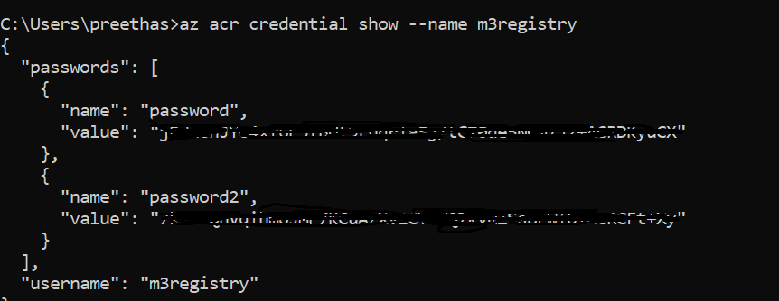

# Create an azure container instance

Azure Container Instances (ACI) is a managed service that allows you to run Docker containers

directly on Azure without needing to manage the underlying virtual machines or orchestration

**az container create --resource-group myResourceGroup --name m3instance --image m3registry.azurecr.io/m4img1:latest --dns-name-label m4img1 --ports 5000 --ip-address Public**



# Check if azure instance is created

**az container show --resource-group myResourceGroup --name m3instance**

## Check if the container has started

**az container list --output table**



## Use the ipaddress in a curl request

**curl -X POST http://4.156.132.129:5000/predict ^**

**-H "Content-Type: application/json" ^**

**-d "{\"Pclass\": 3, \"Sex_encoded\": 0, \"Age\": 22, \"SibSp\": 1, \"Parch\": 0, \"Fare\": 7.25, \"Embarked_encoded\": 0}"**



Use the above url **http://4.156.132.129:5000/predict** in javascript code

## Following error will be seen

Access to fetch at 'http://4.156.132.129:5000/predict' from origin 'http://10.233.26.39:5000' has been blocked by CORS policy: Response to preflight request doesn't pass access control check: No 'Access-Control-Allow-Origin' header is present on the requested resource. If an opaque response serves your needs, set the request's mode to 'no-cors' to fetch the resource with CORS disabled.

CORS is a security feature implemented by browsers to prevent malicious websites from making unauthorized requests to your server. To allow your server to respond to requests from different origins, you need to configure CORS properly.

## Application needs to be configured with Flask CORS

